Date _______________

Dear ,

This week in class, we have been learning all about the parts of our brain involved in emotional regulation.
We learned that when we are regulated (balanced and connected), we can access our prefrontal cortex, where we can learn, create, and plan.
Creating a silly story or Mad Lib™ together is a fun way to tie that lesson into further learning and emotional connection at home.
It can also be fun to make your own homemade Mad Lib™.
- Start by writing a short story.
- Erase random nouns, adjectives, verbs, and adverbs.
- Under those new blank spaces, add labels for parts of speech you erased (noun, verb, adjective, adverb, etc.).
- Have each family member take turns filling in the blanks using their own words.
- Read the story to everyone - and enjoy a good laugh!
You also have the option to use the Mad Lib ™ I included, or you can find plenty of free examples online.
I hope you and your family enjoy exploring more about how the parts of our brain work together to help us regulate our emotions.
Sincerely,
YOUR NAME

Date _______________

Dear ,

This week in class, we learned many focused attention practices and other regulation skills that help when we feel sad, worried, or anxious (dysregulated).
Included you will find a script you can read to your child that prompts them to tighten their muscles and then release them. This activity promotes awareness and recognition of their body and is a great way to relax both physically and mentally. You may find it especially helpful at bedtime if your child has trouble sleeping.

Sincerely,
YOUR NAME

Date _______________

Dear ,

This week in class, we learned how mindfulness and meditation help us feel present and enable us to return to focus. This home strategy helps children feel more in control when they are anxious.
I have included a poster with a picture of a dial on it to help your child focus by having a visual to look at.

Dial It Down
- Direct your child to visualize where their emotion is on a dial by rating it from minimum intensity to maximum intensity.
- Have them visualize turning down the power and strength of the worry. Encourage them to take deep, slow breaths while they turn the power of their emotions down.
- Let students know that they can manage the impact of their stress by noting where it is on the dial, then picturing it decreasing by taking control of the dial and turning it down.

I hope this activity gives your child another tool to help them feel more control when they are anxious.

Sincerely,
YOUR NAME

Date _______________

Dear ,

This week was focused on grounding and gratitude. Deep breathing grounds and settles us when we are nervous. The 4-7-8 breathing exercise created by Dr. Andrew Weil calms the mind, quiets thoughts, and gives children a sense of control, letting their nervous system know they are safe. This technique increases oxygen to the body and encourages a return to a resting heart rate. It tells the body to slow down and rest. This will help children with pain relief and is especially effective at bedtime.
Lead your child in the following:
- Sit or lie down, whichever feels most safe and comfortable, and blow out all the air in your lungs.
- Inhale through your nose to the count of four.
- Hold your breath for the count of seven.
- Exhale through your mouth to the count of eight, making an audible “whoosh” sound.
- Repeat four times.

I hope you find this breathing technique helpful for your child – and you as well!

Sincerely,
YOUR NAME

Date _______________

Dear ,

This week we learned some fun brain breaks that are quick activities designed to create a state of relaxed alertness, priming the brain for learning. The suggested activity here would be great to do before homework, an athletic practice, a music lesson, or any activity that can cause worry and is more appropriate for home than school. If this activity doesn’t work for your family, ask your child to teach you “Spock and Spidey” and “Makin’ Waves”!

Belly Laughs
Each family member places their head on another person’s tummy so that everyone is connected. The first person says “Ha,” then the second person says “Ha-ha,” the third person says “Ha-Ha-Ha,” and so on. The goal is to get through the group without anyone laughing. Right, like that will ever happen! It’s infectious and contagious! This can feel vulnerable for some, so with this or any other exercise, always make it optional and not required.

I hope this fun activity brings connection and gets you all laughing!

Sincerely,
YOUR NAME

Date _______________

Dear ,

This week we learned all about Restorative Practices. Home is a great place to implement practices that allow healing when things don’t go as planned (sibling fights, anyone?). The key is to build relationships within the home among all family members through nurturing activities that increase family cohesion and “felt safety” so that when tough conversations need to happen, they can take place without emotional walls and fighting.
Family Circles are a great way to have connecting conversations. Take turns letting family members choose the topic, and then each person shares their response at mealtimes, during car rides, or any other time you are happily (or unhappily) stuck together.
Here are a few ideas (and kids are great at coming up with their own!):
- Glow and Grow: Share one thing you shined in today and one you want to work on and improve.
- SOS: Share what you need help with.
- Detective: Share what good you observed today.
- Kindness Planner: Share your plan for helping someone tomorrow.
These connected conversations and circles build an excellent foundation for when the tougher conversations need to happen. You can also prepare for those challenging moments by teaching conflict resolution and repair skills.
Disagreements in the home are normal and unavoidable. We can teach our children that everyone makes mistakes, and we can fix those mistakes. Apologies are the foundation of how we restore broken relationships. Apologies don’t need to be shameful, embarrassing, or forced. An inauthentic apology does not fully resolve the conflict.
Rather than encouraging a child to “go apologize to your brother,” it helps to give them a sentence starter with some specific wording. Roleplay and practice with them so they don’t lose courage in the moment.
- I am sorry I...
- It was my fault that happened. I apologize for letting it happen.
- I realize that…
- I realize that was my fault and I am sorry for making you feel .
- I am truly sorry that I did this. I want to make things better. How can I do that?
- I am so sorry. Here is my plan on how to make things right…

In fixing what was broken, the repair should:
- Help a child feel reconnected to the family.
- Be directly connected to the harm caused (logical consequences).
- Support learning and skill building.

Teaching children how to accept an apology is just as important if the rupture is to be fully repaired.
- I accept your apology.
- I’ll accept your apology because…
- I felt when that happened, thank you for apologizing.
- Thank you for apologizing. I still need to think about it. I am feeling ,

I hope these exercises help restore relationships when the inevitable disagreements happen in the home.

Sincerely,
YOUR NAME

Date _______________

Dear ,

This week we learned about our Window of Tolerance and that we don’t need to be afraid of stress because we can manage it by asking for help. We created a regulation rescue plan at school that I am sure your child would be interested in sharing!
We can tie this into home learning by teaching the concept of “felt safety.” In the classroom, and at home, even when the environment is physically safe, children may not feel emotionally safe. The following meme is a great place for us to start.
I hope you and your child have a great discussion about how they can better manage the stress they encounter.

Sincerely,
YOUR NAME

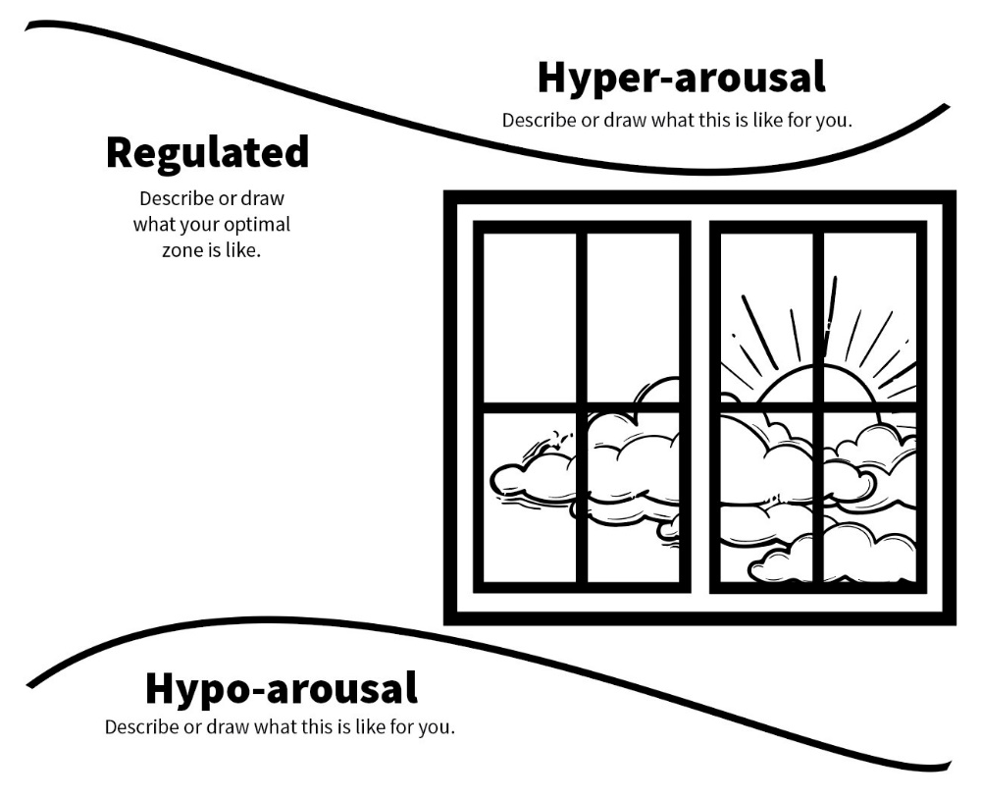

Date _______________

Dear ,

This week we learned some strategies that strengthen the pathway to the prefrontal cortex of our brain! This game promotes reciprocal exchanges that foster connection and playfulness, leading to emotional regulation while strengthening family bonds.

Story Add and Pass
Start the game and story by saying, “Once upon a time…” or make up your own beginning. Then wink when you are ready for them to add on and continue the story. They can add as much as they want.
As they get ready to “pass” the story on, have them set up a cliffhanger for the next family member to continue the story, going back and forth until the story ends.

I hope you find this fun game builds connection with your child.

Sincerely,
YOUR NAME

